Clean Code Principles - Use the Right Constructs
# Source: AI Source: Provided by: [Data Path: Persons Table -> ID Column: 1, Name_En Column: Motasem Essam] -> From: [Chatgpt (GPT‑5 Mini)] on [12/9/2025]
Using the right constructs means choosing the most appropriate language feature or structure to clearly express your intent.
👉 Write code that says exactly what you mean, using the best tool available.

🔑 Why It Matters
# Source: AI Source: Provided by: [Data Path: Persons Table -> ID Column: 1, Name_En Column: Motasem Essam] -> From: [Chatgpt (GPT‑5 Mini)] on [12/9/2025]
- Improves readability and clarity
- Makes code more expressive
- Reduces complexity
- Helps others understand your intent quickly

❌ Bad Example (Using Wrong Construct)
# Source: AI Source: Provided by: [Data Path: Persons Table -> ID Column: 1, Name_En Column: Motasem Essam] -> From: [Chatgpt (GPT‑5 Mini)] on [12/9/2025]
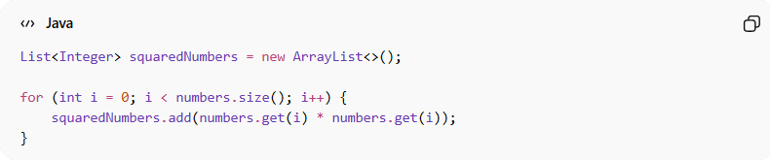
List<Integer> squaredNumbers = new ArrayList<>();

for (int i = 0; i < numbers.size(); i++) {
squaredNumbers.add(numbers.get(i) * numbers.get(i));
}
👉 Problems:
- Manual loop when a better construct exists
- More verbose than necessary

✅ Good Example (Using Better Construct)
# Source: AI Source: Provided by: [Data Path: Persons Table -> ID Column: 1, Name_En Column: Motasem Essam] -> From: [Chatgpt (GPT‑5 Mini)] on [12/9/2025]
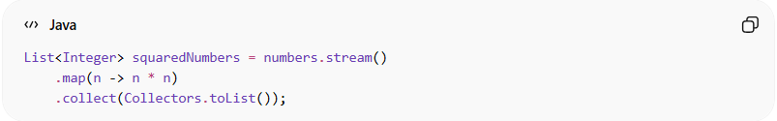
List<Integer> squaredNumbers = numbers.stream()
.map(n -> n * n)
.collect(Collectors.toList());
👉 Benefits:
- More expressive
- Clearly shows transformation
- Less boilerplate code

❌ Another Bad Example
# Source: AI Source: Provided by: [Data Path: Persons Table -> ID Column: 1, Name_En Column: Motasem Essam] -> From: [Chatgpt (GPT‑5 Mini)] on [12/9/2025]
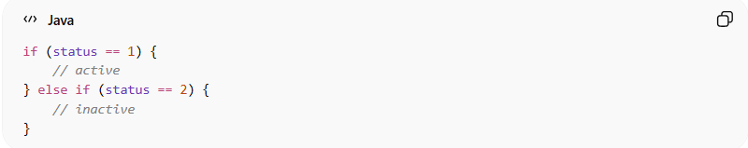
if (status == 1) {
// active
} else if (status == 2) {
// inactive
}
👉 Problem:
- Magic numbers
- Not clear what 1 or 2 means

✅ Good Example (Using Enum)
# Source: AI Source: Provided by: [Data Path: Persons Table -> ID Column: 1, Name_En Column: Motasem Essam] -> From: [Chatgpt (GPT‑5 Mini)] on [12/9/2025]
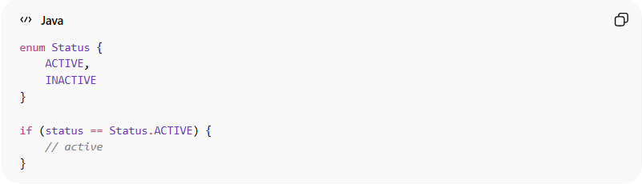
enum Status {
ACTIVE,
INACTIVE
}

if (status == Status.ACTIVE) {
// active
}
👉 Benefits:
- Self-explanatory
- Type-safe
- Easier to maintain

❌ Another Bad Example
# Source: AI Source: Provided by: [Data Path: Persons Table -> ID Column: 1, Name_En Column: Motasem Essam] -> From: [Chatgpt (GPT‑5 Mini)] on [12/9/2025]
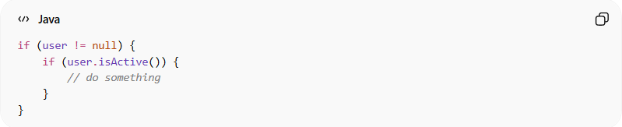
if (user != null) {
if (user.isActive()) {
// do something
}
}

✅ Better Example (Cleaner Construct)
# Source: AI Source: Provided by: [Data Path: Persons Table -> ID Column: 1, Name_En Column: Motasem Essam] -> From: [Chatgpt (GPT‑5 Mini)] on [12/9/2025]
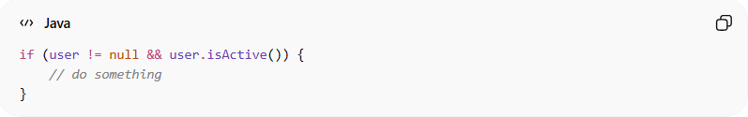
if (user != null && user.isActive()) {
// do something
}

💡 Key Idea
# Source: AI Source: Provided by: [Data Path: Persons Table -> ID Column: 1, Name_En Column: Motasem Essam] -> From: [Chatgpt (GPT‑5 Mini)] on [12/9/2025]
Choose constructs that make your code clear, concise, and expressive, not just working.

🚫 Common Mistakes
# Source: AI Source: Provided by: [Data Path: Persons Table -> ID Column: 1, Name_En Column: Motasem Essam] -> From: [Chatgpt (GPT‑5 Mini)] on [12/9/2025]
- Using loops instead of higher-level constructs (map/filter)
- Using magic numbers instead of enums/constants
- Writing overly complex conditions
- Ignoring language features that simplify code

🧾 Summary
# Source: AI Source: Provided by: [Data Path: Persons Table -> ID Column: 1, Name_En Column: Motasem Essam] -> From: [Chatgpt (GPT‑5 Mini)] on [12/9/2025]
Using the right constructs helps you:
- Write cleaner and more expressive code
- Reduce complexity and boilerplate
- Improve readability and maintainability

